Question 1 – Healthcare Analytics
R Program
library(ggplot2)
patient <- data.frame(
Patient = c("P1","P2","P3","P4","P5","P6","P7","P8"),
Age = c(24,32,41,48,56,65,38,29),
BMI = c(19.8,24.5,28.1,30.3,33.2,36.5,26.2,22.1),
BP = c(110,118,132,145,152,168,124,116),
Severity = factor(c("Low","Medium","High","High",
"Critical","Critical","Medium","Low"),
levels=c("Low","Medium","High","Critical"))
)
ggplot(patient,
aes(x=Age,
y=BP,
color=Severity,
size=BMI))+
geom_point(alpha=0.8)+
scale_color_manual(values=c("green","gold","orange","red"))+
labs(title="Healthcare Risk Analysis",
x="Age",
y="Blood Pressure",
color="Disease Severity",
size="BMI")+
theme_minimal()
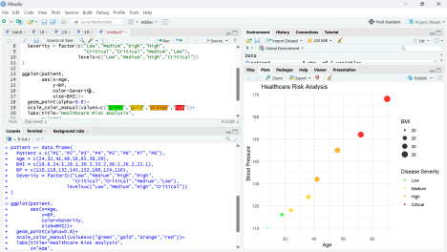
Justification
● Age (X-axis): Represents progression of age.
● Blood Pressure (Y-axis): Shows cardiovascular condition.
● Disease Severity (Color):
○ Green → Low
○ Yellow → Medium
○ Orange → High
○ Red → Critical
● BMI (Point Size): Larger circles indicate higher BMI.
Interpretation
● Blood pressure generally increases with age.
● Higher BMI patients have higher blood pressure.
● Critical patients are clearly visible due to the red color.
● Multiple health indicators are represented in one visualization.
Question 2 – Climate Science
(a) Cartesian Line Chart
library(ggplot2)
climate <- data.frame(
Month=c("Jan","Feb","Mar","Apr","May","Jun", "Jul","Aug","Sep","Oct","Nov","Dec"), Temperature=c(20,23,29,35,39,36,32,31,30,28,24,21), Rainfall=c(25,18,12,8,5,65,150,170,120,85,45,30) )
ggplot(climate,aes(Month,Temperature,group=1))+ geom_line(color="blue",size=1.2)+
geom_point(size=3,color="red")+
labs(title="Monthly Temperature Variation", x="Month",
y="Temperature (°C)")+
theme_minimal()
(b) Polar Coordinate Chart
ggplot(climate,
aes(x=Month,y=Rainfall,fill=Rainfall))+
geom_bar(stat="identity")+
coord_polar()+
scale_fill_gradient(low="lightblue",high="darkblue")+ labs(title="Annual Rainfall (Polar Chart)")+ theme_minimal()
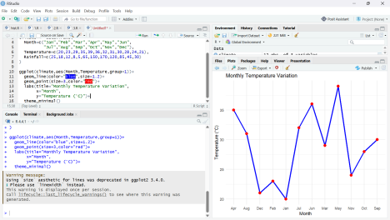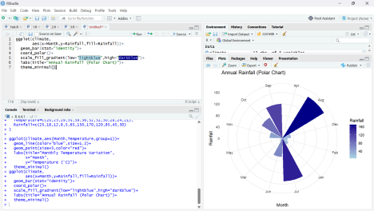
Comparison
Cartesian Chart Advantages
● Accurate comparison of monthly values. ● Easy to identify trends.
● Best for continuous variables.
Cartesian Chart Limitations
● Less attractive for cyclic data.
● Does not emphasize seasonal repetition. Polar Chart Advantages
● Clearly represents seasonal cycles. ● Easy to identify wet and dry periods. ● Attractive circular representation.
Polar Chart Limitations
● Exact values are harder to compare. ● Can distort perception of bar lengths.
Question 3 – Business Analytics & Marketing
R Program
library(ggplot2)
business <- data.frame(
Product=c("A","B","C","D","E"),
Sales=c(210,185,260,145,120),
Profit=c(18,14,25,12,10),
MarketShare=c(24,20,28,15,13)
)
business$Highlight <- ifelse(business$MarketShare== max(business$MarketShare),
"Highest","Normal")
ggplot(business,
aes(Product,
Sales,
fill=Profit))+
geom_bar(stat="identity")+
geom_text(aes(label=Sales),vjust=-0.4)+
scale_fill_gradient(low="lightgreen",high="darkgreen")+ geom_bar(data=subset(business,Highlight=="Highest"), fill="red",stat="identity")+
labs(title="Sales and Profit Analysis",
fill="Profit (%)")+
theme_minimal()
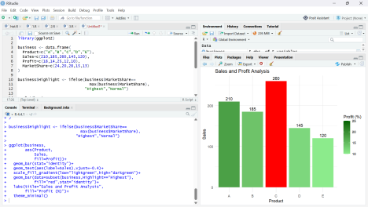Justification
● Bar Height: Sales amount.
● Sequential Green Color: Indicates increasing profit.
● Red Highlight: Highest market share immediately attracts attention.
Interpretation
● Product C has highest sales.
● Product C also has highest market share.
● Green shades show profitability levels.
● Managers can easily identify top-performing products.
Question 4 – Transportation Engineering
R Program
library(ggplot2)
traffic <- data.frame(
Direction=c("North","North-East","East",
"South-East","South",
"South-West","West","North-West"),
Vehicles=c(980,760,1240,890,1420,1130,860,720)
)
ggplot(traffic,
aes(Direction,
Vehicles,
fill=Vehicles))+
geom_bar(stat="identity")+
coord_polar()+
scale_fill_gradient(low="yellow",high="red")+
labs(title="Traffic Flow by Direction")+
theme_minimal()
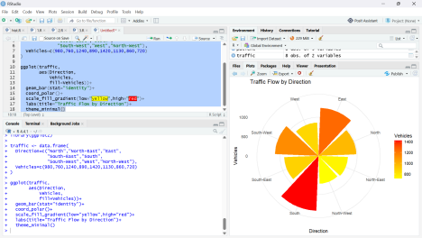
Justification
● Yellow indicates low traffic.
● Red indicates high traffic.
● Circular layout matches compass directions.
Interpretation
● South has maximum traffic.
● North-West has minimum traffic.
● East also experiences heavy traffic.
Why Polar Chart?
● Directions naturally form a circle.
● Better represents compass-based traffic.
● Easier to compare directional flow.
● More meaningful than a normal bar chart for geographic orientation.
Question 5 – Environmental Sustainability Dashboard
R Program
library(ggplot2)
library(gridExtra)
city <- data.frame(
City=c("A","B","C","D","E","F"),
AQI=c(48,82,135,165,72,95),
GreenCover=c(45,32,21,18,38,30),
CO2=c(1.8,3.5,5.6,7.4,2.9,4.2),
Population=c(9,15,22,28,12,18)
)
city$AQI_Category <- cut(city$AQI,
breaks=c(0,50,100,150,200),
labels=c("Good","Moderate","Poor","Very Poor"))
p1 <- ggplot(city,
aes(City,AQI,fill=AQI_Category))+
geom_bar(stat="identity")+
scale_fill_manual(values=c("green",
"yellow",
"orange",
"red"))+
theme_minimal()
p2 <- ggplot(city,
aes(GreenCover,CO2,
size=Population,
color=AQI_Category))+
geom_point(alpha=0.8)+
scale_color_manual(values=c("green",
"yellow",
"orange",
"red"))+
theme_minimal()
grid.arrange(p1,p2,ncol=2)
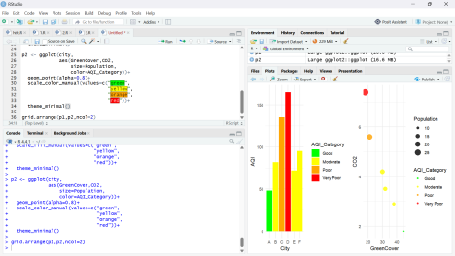Dashboard Design Choices
Visualization 1
● Bar Chart → Compare AQI across cities.
Visualization 2
● Scatter Plot
○ X-axis → Green Cover
○ Y-axis → CO₂ Emission
○ Size → Population
○ Color → AQI Category
Continuous Scales
● Population represented using point size.
● CO₂ and Green Cover represented using continuous axes.
AQI Color Palette
● Green → Good
● Yellow → Moderate
● Orange → Poor
● Red → Very Poor
Justification
● Colors instantly indicate pollution severity.
● Scatter plot shows the relationship between green cover and CO₂ emissions. ● Population size adds another analytical dimension.
● Dashboard enables comparison of multiple sustainability indicators simultaneously.

